Name: Laiba Asim
Sap id: 65230
Lab 10

Task 1:

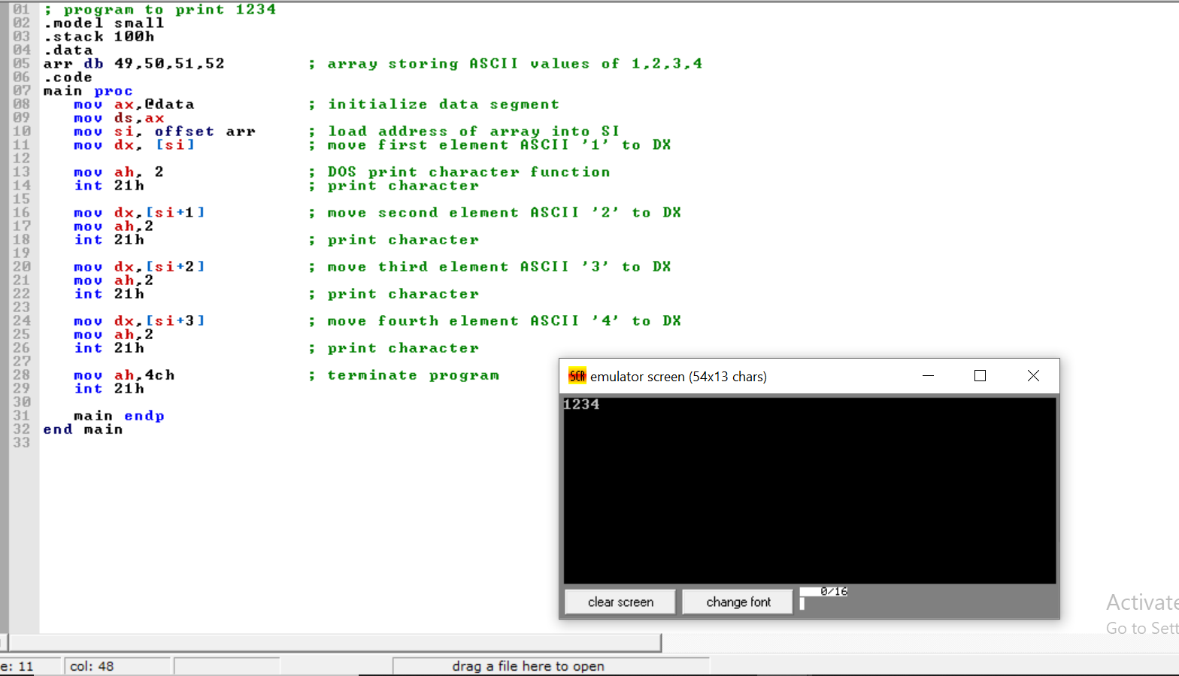

Task2
